Cover Page

CU Robosub team

(date of release)

Name of the Board

Add a nice picture here

# 

**Abstract** **3**

**Design Requirements** **3**

**Design Overview** **3**

Previous designs 3

**System descriptions** **4**

5V line 5

12V line 6

19V line 7

48V line 7

**System status** **8**

**Known Issues** **8**

**Appendix** **8**

# 

# Abstract

The Power conversion board takes in 14.8V from the merge circuit board through the backplane and converts it into various voltage levels to power each of the other electrical systems on the UAV. The power conversion board will also contain a microcontroller for current sensing.

# Design Requirements

|  |  |
| --- | --- |
| Description | Specifications |
| 5V line | 1A buck - No Peripherals Internal to Sub |
| 12V line | 3A buck - Hydrophones, Pneumatic Systems, and Pressure Sensor |
| 19v line | 4A boost - Computer |
| 48V line | .5A boost - Down Cam |
| 48V line | .5A boost - DVL Power |

# Design Overview

#TODO give information about the parts used and the design process

## Previous designs

Design V1.0 was not of sufficient quality. It had no reverse bias protection which caused it to fail when brought to competition. (#TODO add details about parts used and what was done right I believe it was the LTC3958?)

# 

# System descriptions

Shown below is the completed power design board. Red represents top layer traces while blue represents bottom level traces. Each subsystem will be described in full within their subsequent system descriptions

## 

## 

## 5V line

This systems consists of taking a R-78E-0.5 low cost switching regulator and adding a few decoupling capacitors to the input and output lines. Followed by a current sensing resistor with a AD8217 Analog Devices high resolution, zero drift current shunt monitor chip. This device utilizes a 5 mF sense resistor to measure current draw as linear voltage based on the current drop across the sense resistor.

Data sheets can be found in Electrical Research > Power Conversion Chips

AD8217.pdf

R -78Exx-0.5.pdf

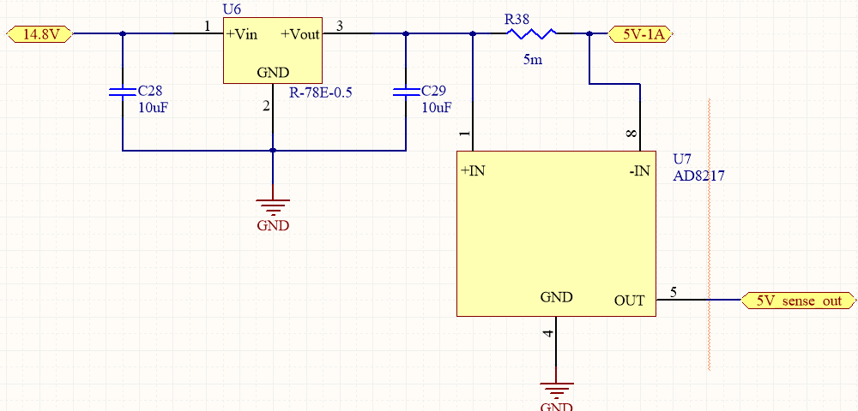

## 12V line

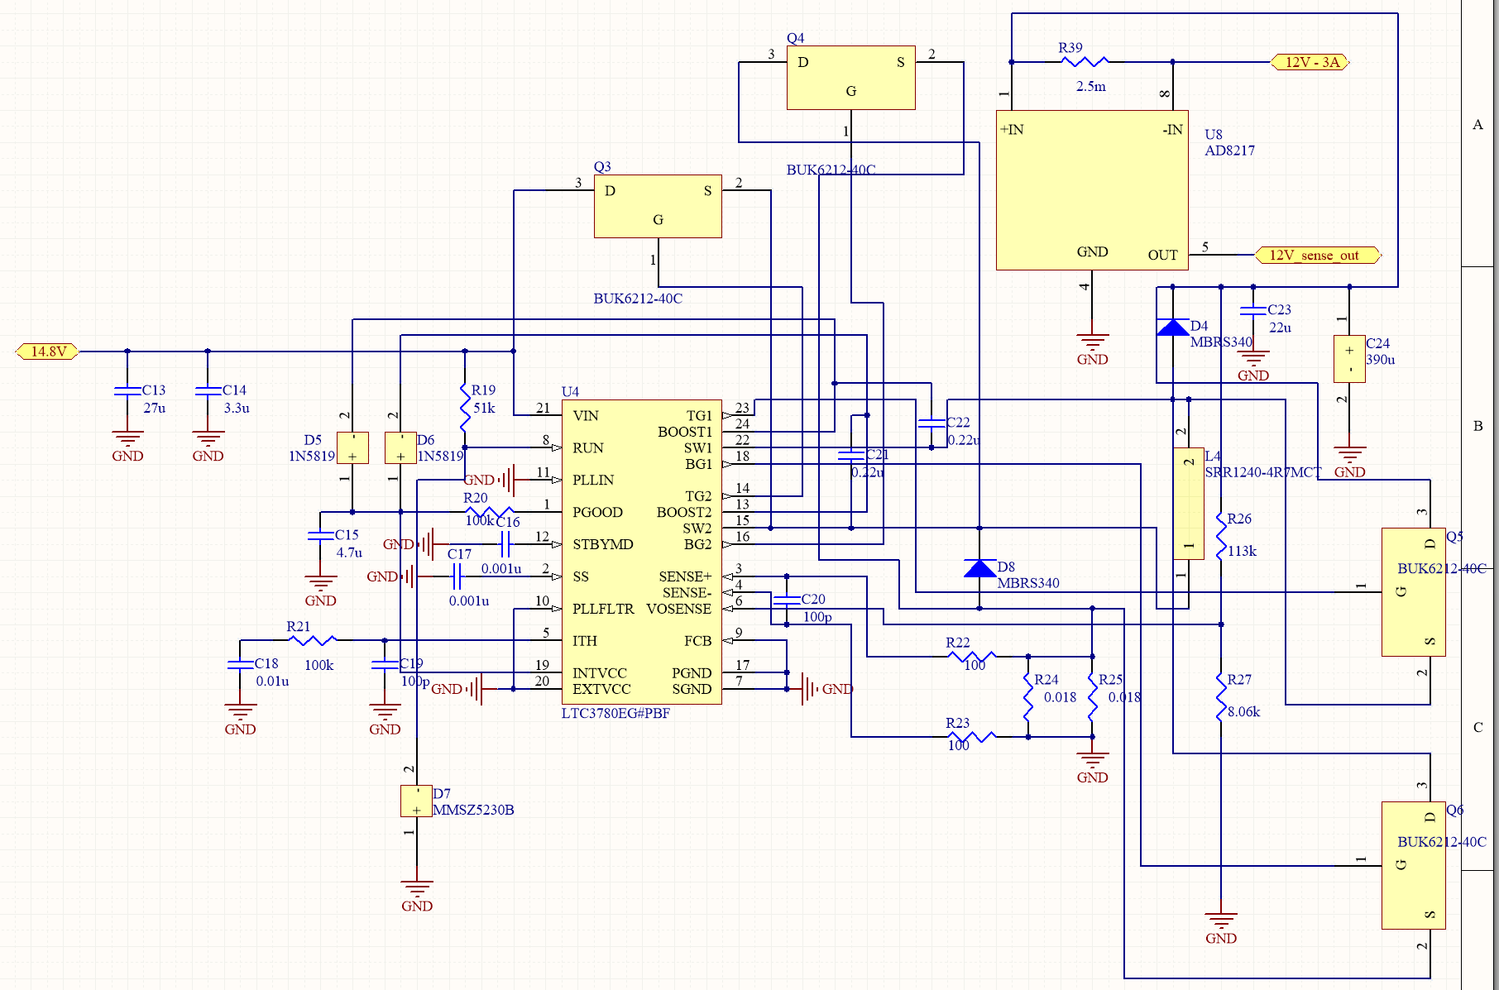

## 19V line

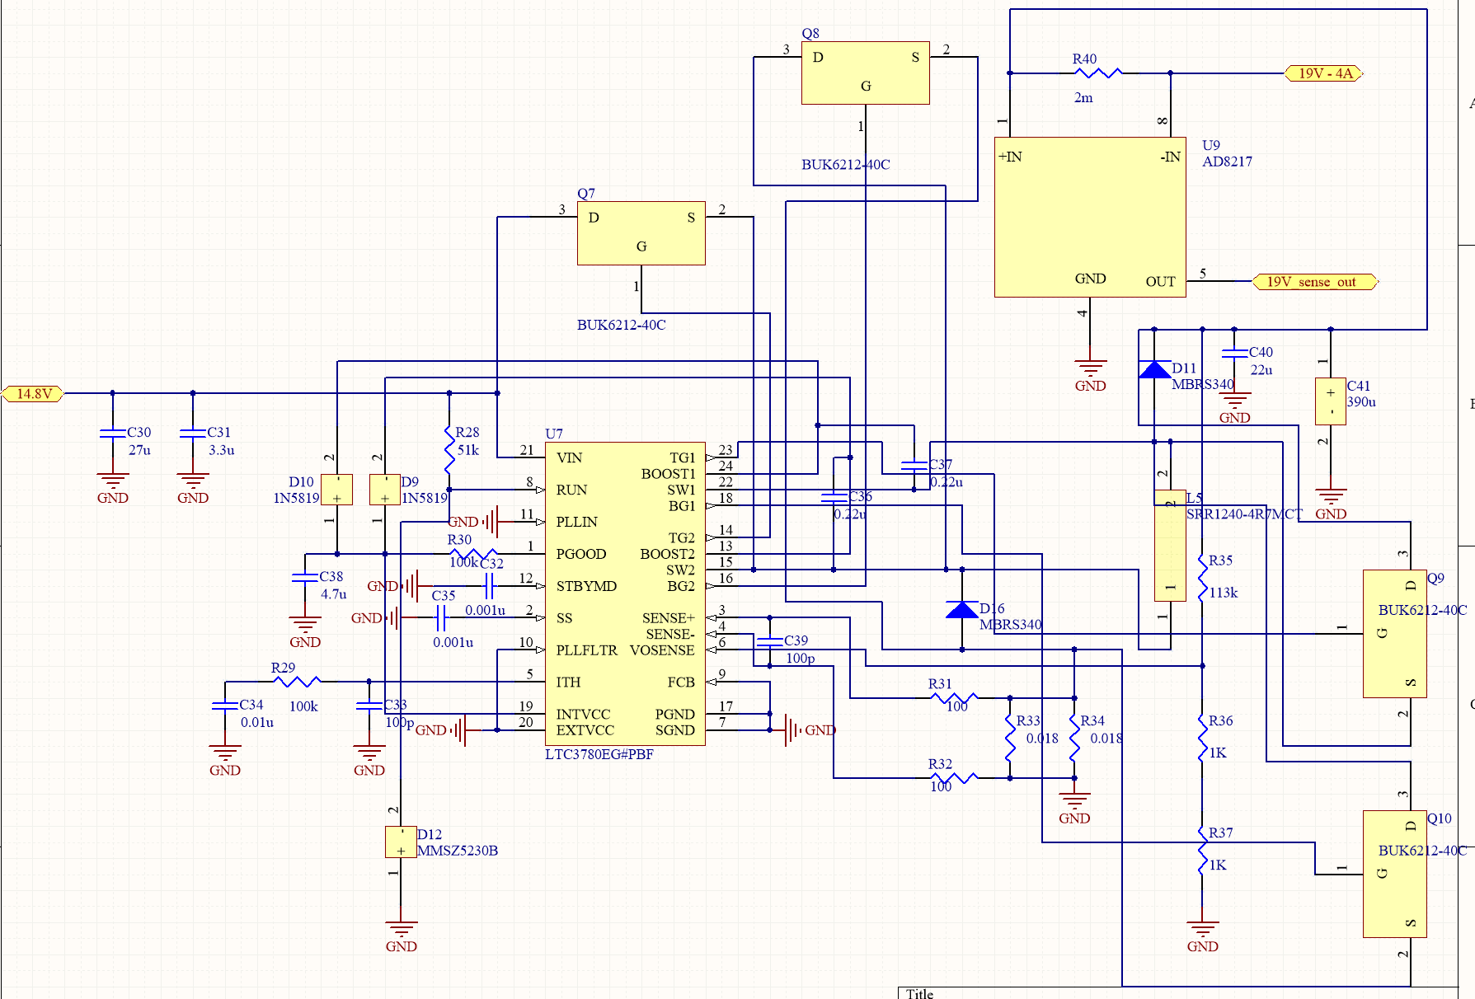

## 48V line

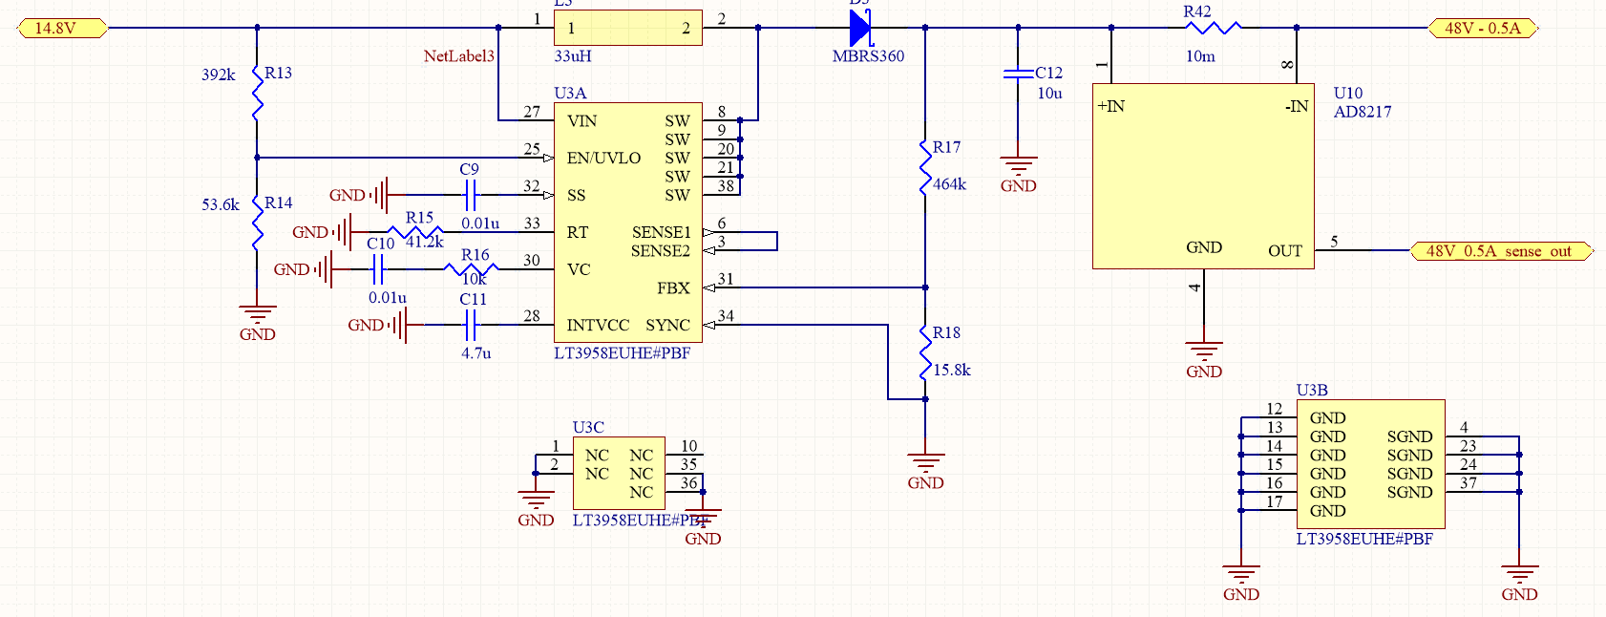

## Microcontroller Monitoring

# System status

This system was completed and ran successfully on the 2017 sub Leviathan.

# Known Issues

* Not able to properly monitor circuit health with arduino micro.
* No power management for proper startup and shutdown of power boards

# Appendix

This is where you will store all of your information on which parts were used and links to their data sheets. Also links to where the Altium files can be found (they should be within the folder this document is stored in) and any citations to resources you found useful in the design process for this part.